**High throughput functional genomics identifies modulators of TCE metabolite genotoxicity and candidate susceptibility genes**

Vanessa Y. De La Rosa, Jonathan Asfaha, Michael Fasullo, Alex Loguinov, Peng Li, Lee E. Moore, Nathaniel Rothman, Jun Nakamura,James Swenberg, Ghislaine Scelo, Luoping Zhang,Martyn T. Smith, Chris D. Vulpe

**SUPPLEMENTARY DATA**

**Figure S1.** Dose response of TCE metabolites DCVG and DCVC in yeast

**Figure S2.** DCVC dose response in translesion synthesis and HR/NER yeast deletion mutants.

**Figure S3.** DT40 DNA repair mutant dose response curves for DCVC and Cisplatin

**Figure S4**. Sensitivity of ICL repair deficient lymphoblasts (PD20) and FANCD2 complemented (PD20D2) cells to DCVC at 24hrs and 72hrs

**Table S1.** Total genes from yeast profiling studies identified as sensitive or resistant to DCVC treatments by differential strain sensitivity analysis (DSSA).

**Table S2**. Mutation frequency of DCVC in human lymphoblast cells

**Table S3.** DT40 mutant cells used in this study

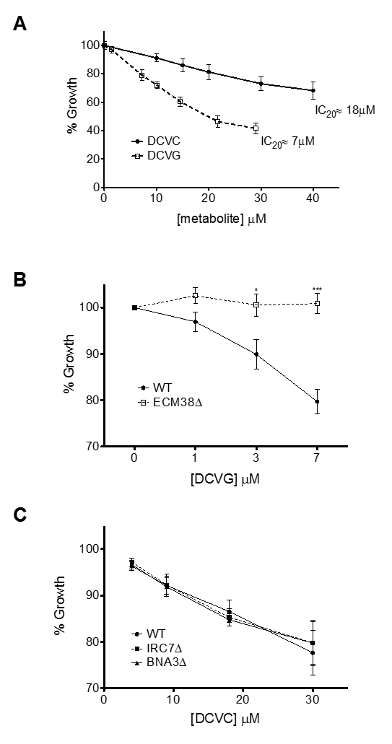

**Figure S1.** Dose response of TCE metabolites DCVG and DCVC in yeast. (A) The IC20 concentration was determined in wild-type yeast and used for functional profiling exposures. Dose response in gamma-glutamyl dipeptidase (B) and beta-lyase yeast deletion mutants Values are mean ± SE; n ≥ 3 for each measurement. Significance values were calculated by two-way ANOVA ***p < 0.001, **p < 0.01, *p < 0.05 *for treated mutant versus treated wild-type.*

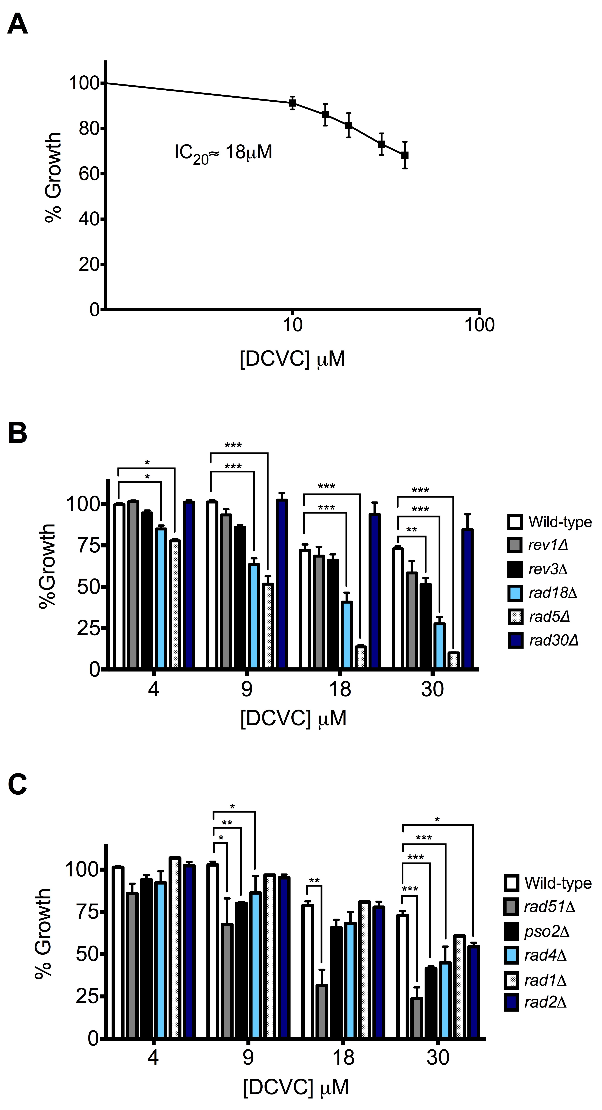**A**

**B.**

**Figure S2.** DCVC dose response in (A) tranlesion synthesis and (B) HR/NER yeast deletion mutants. Values are mean ± SE; n ≥ 3 for each measurement. Significance values were calculated by two-way ANOVA ***p < 0.001, **p < 0.01, *p < 0.05 *for DCVC-treated mutant versus DCVC treated wild-type.*

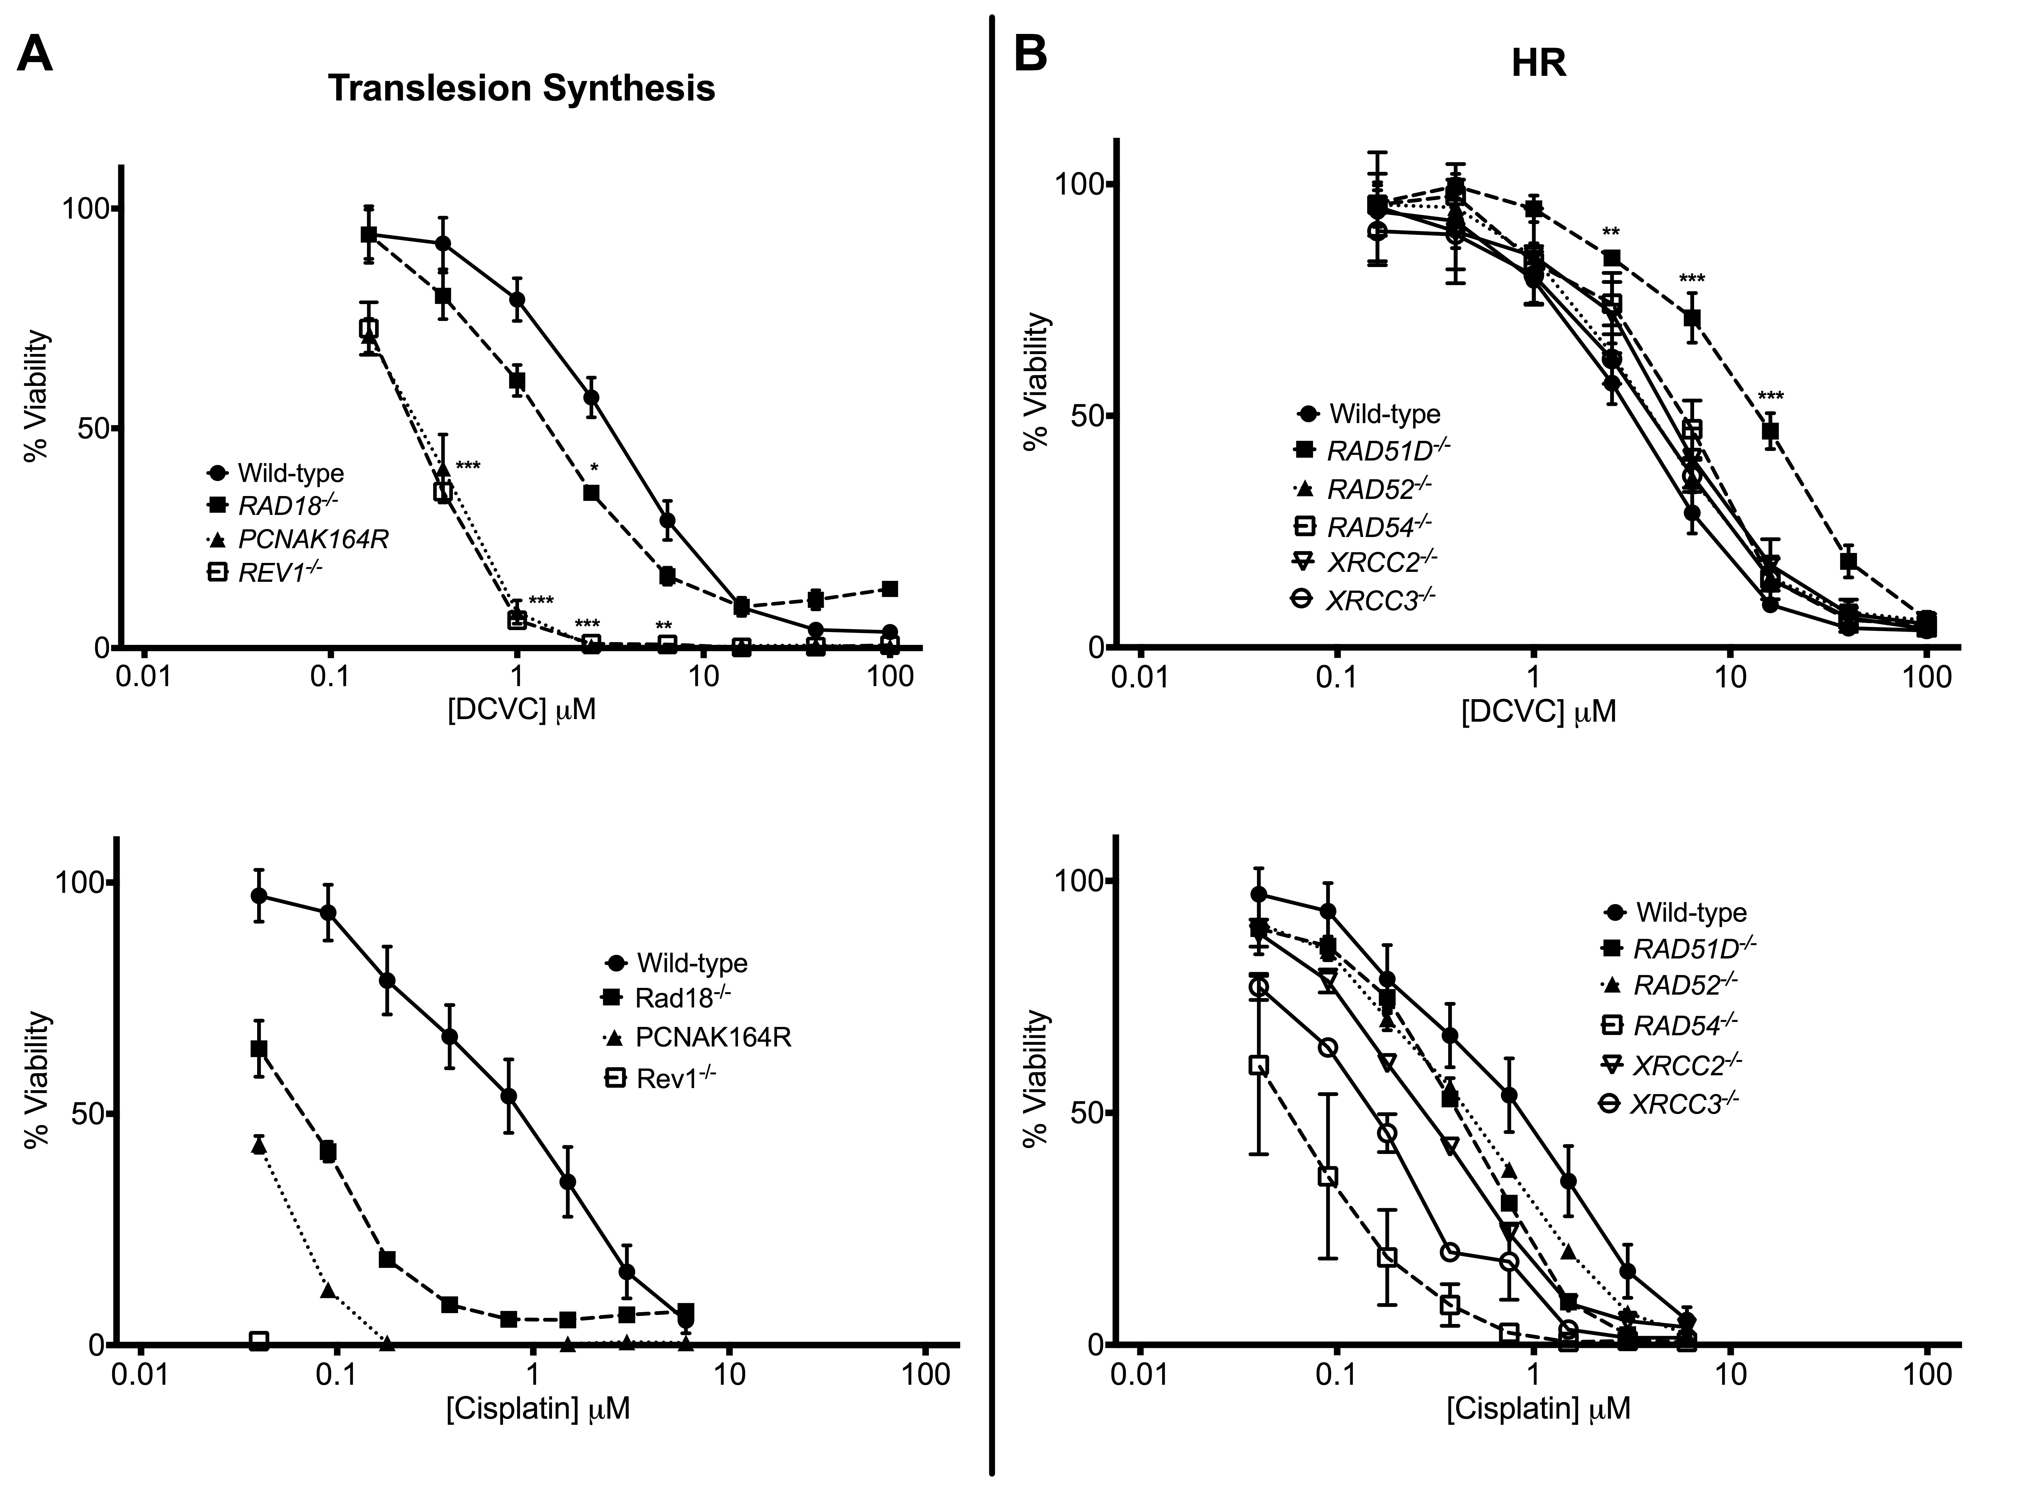

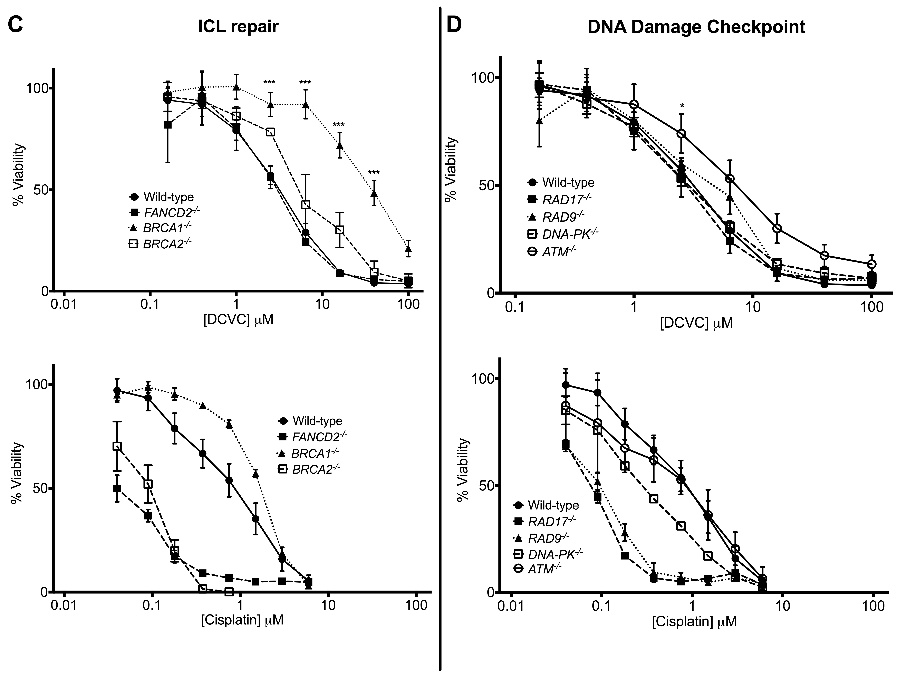

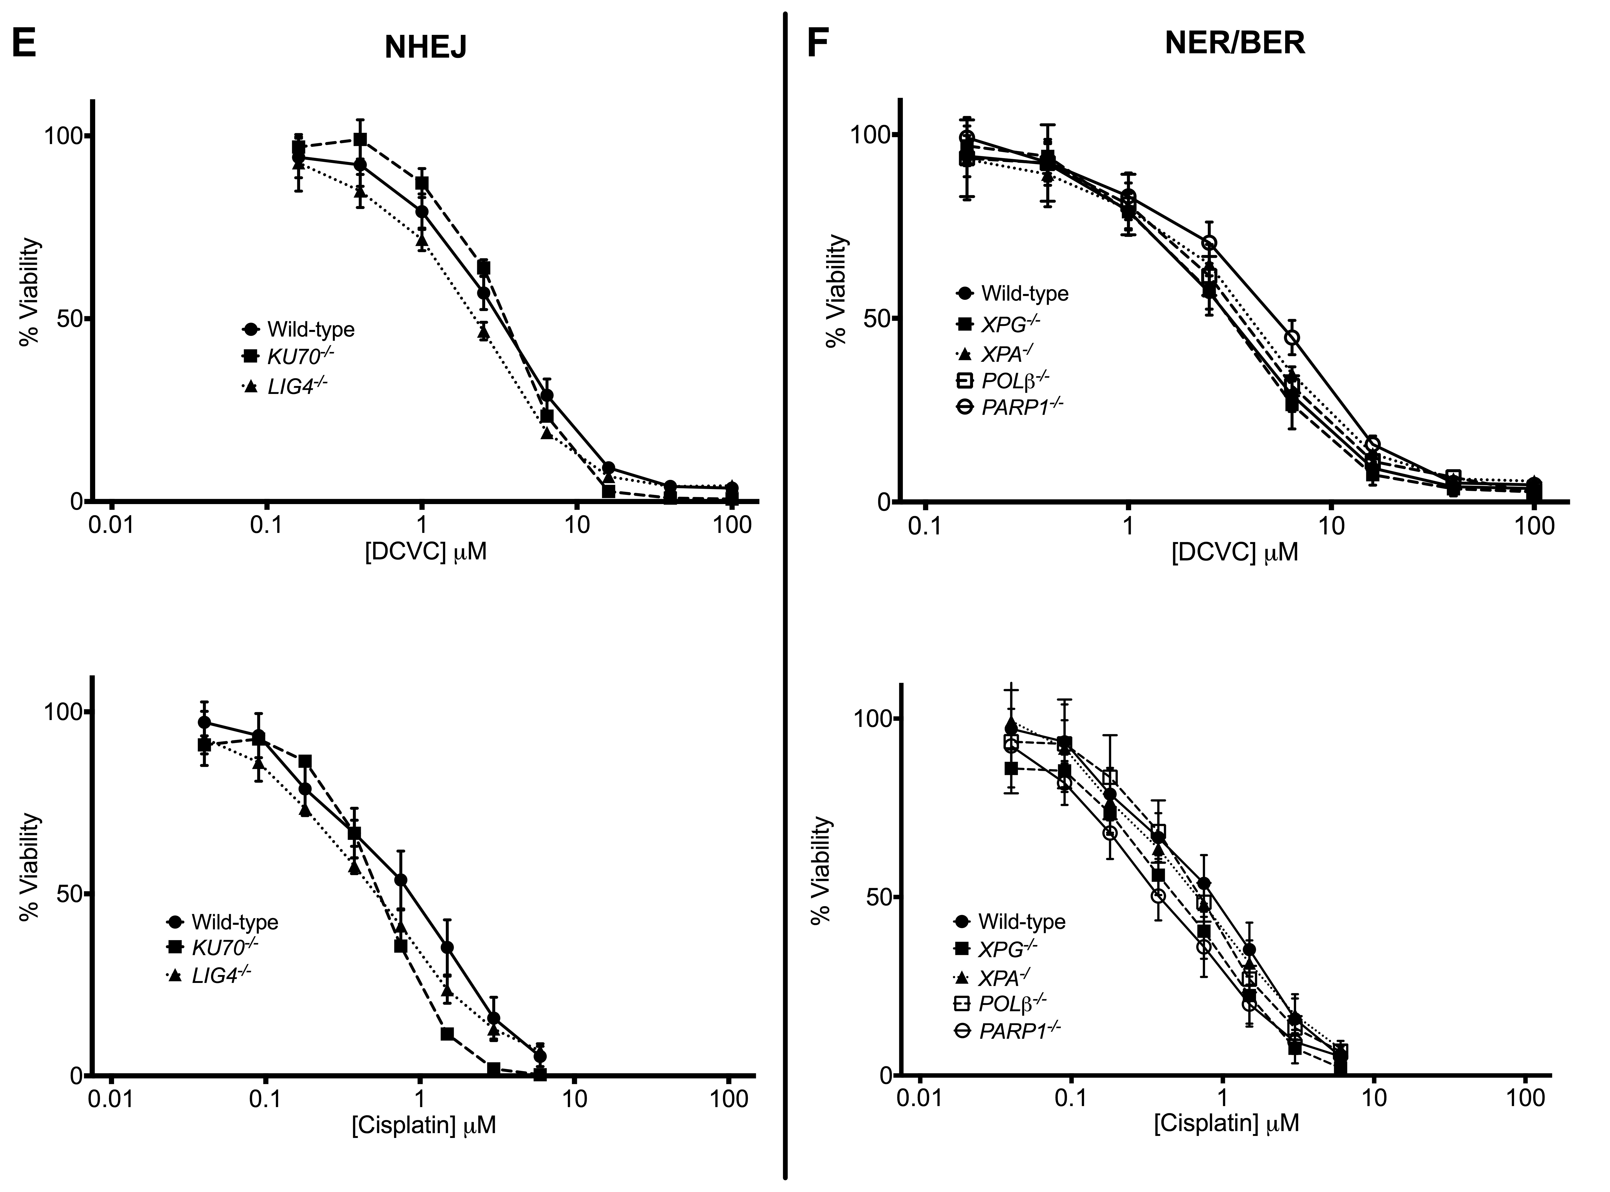



**Figure S3.** DT40 DNA repair mutant dose response curves for DCVC and Cisplatin. (A) Tranlesion synthesis mutants (B) HR mutants (C) ICL mutants (D) DNA damage checkpoint mutants (E) NHEJ mutants (F) NER/BER mutants (G) DNA helicase mutants. Sensitivity was assessed by XTT viability assays. Values are mean ± SE; n ≥ 3 for each measurement. Significant values were calculated by two-way ANOVA, where ***p < 0.001, **p < 0.01, *p < 0.05 *for DCVC-treated mutant versus DCVC treated wild-type.*

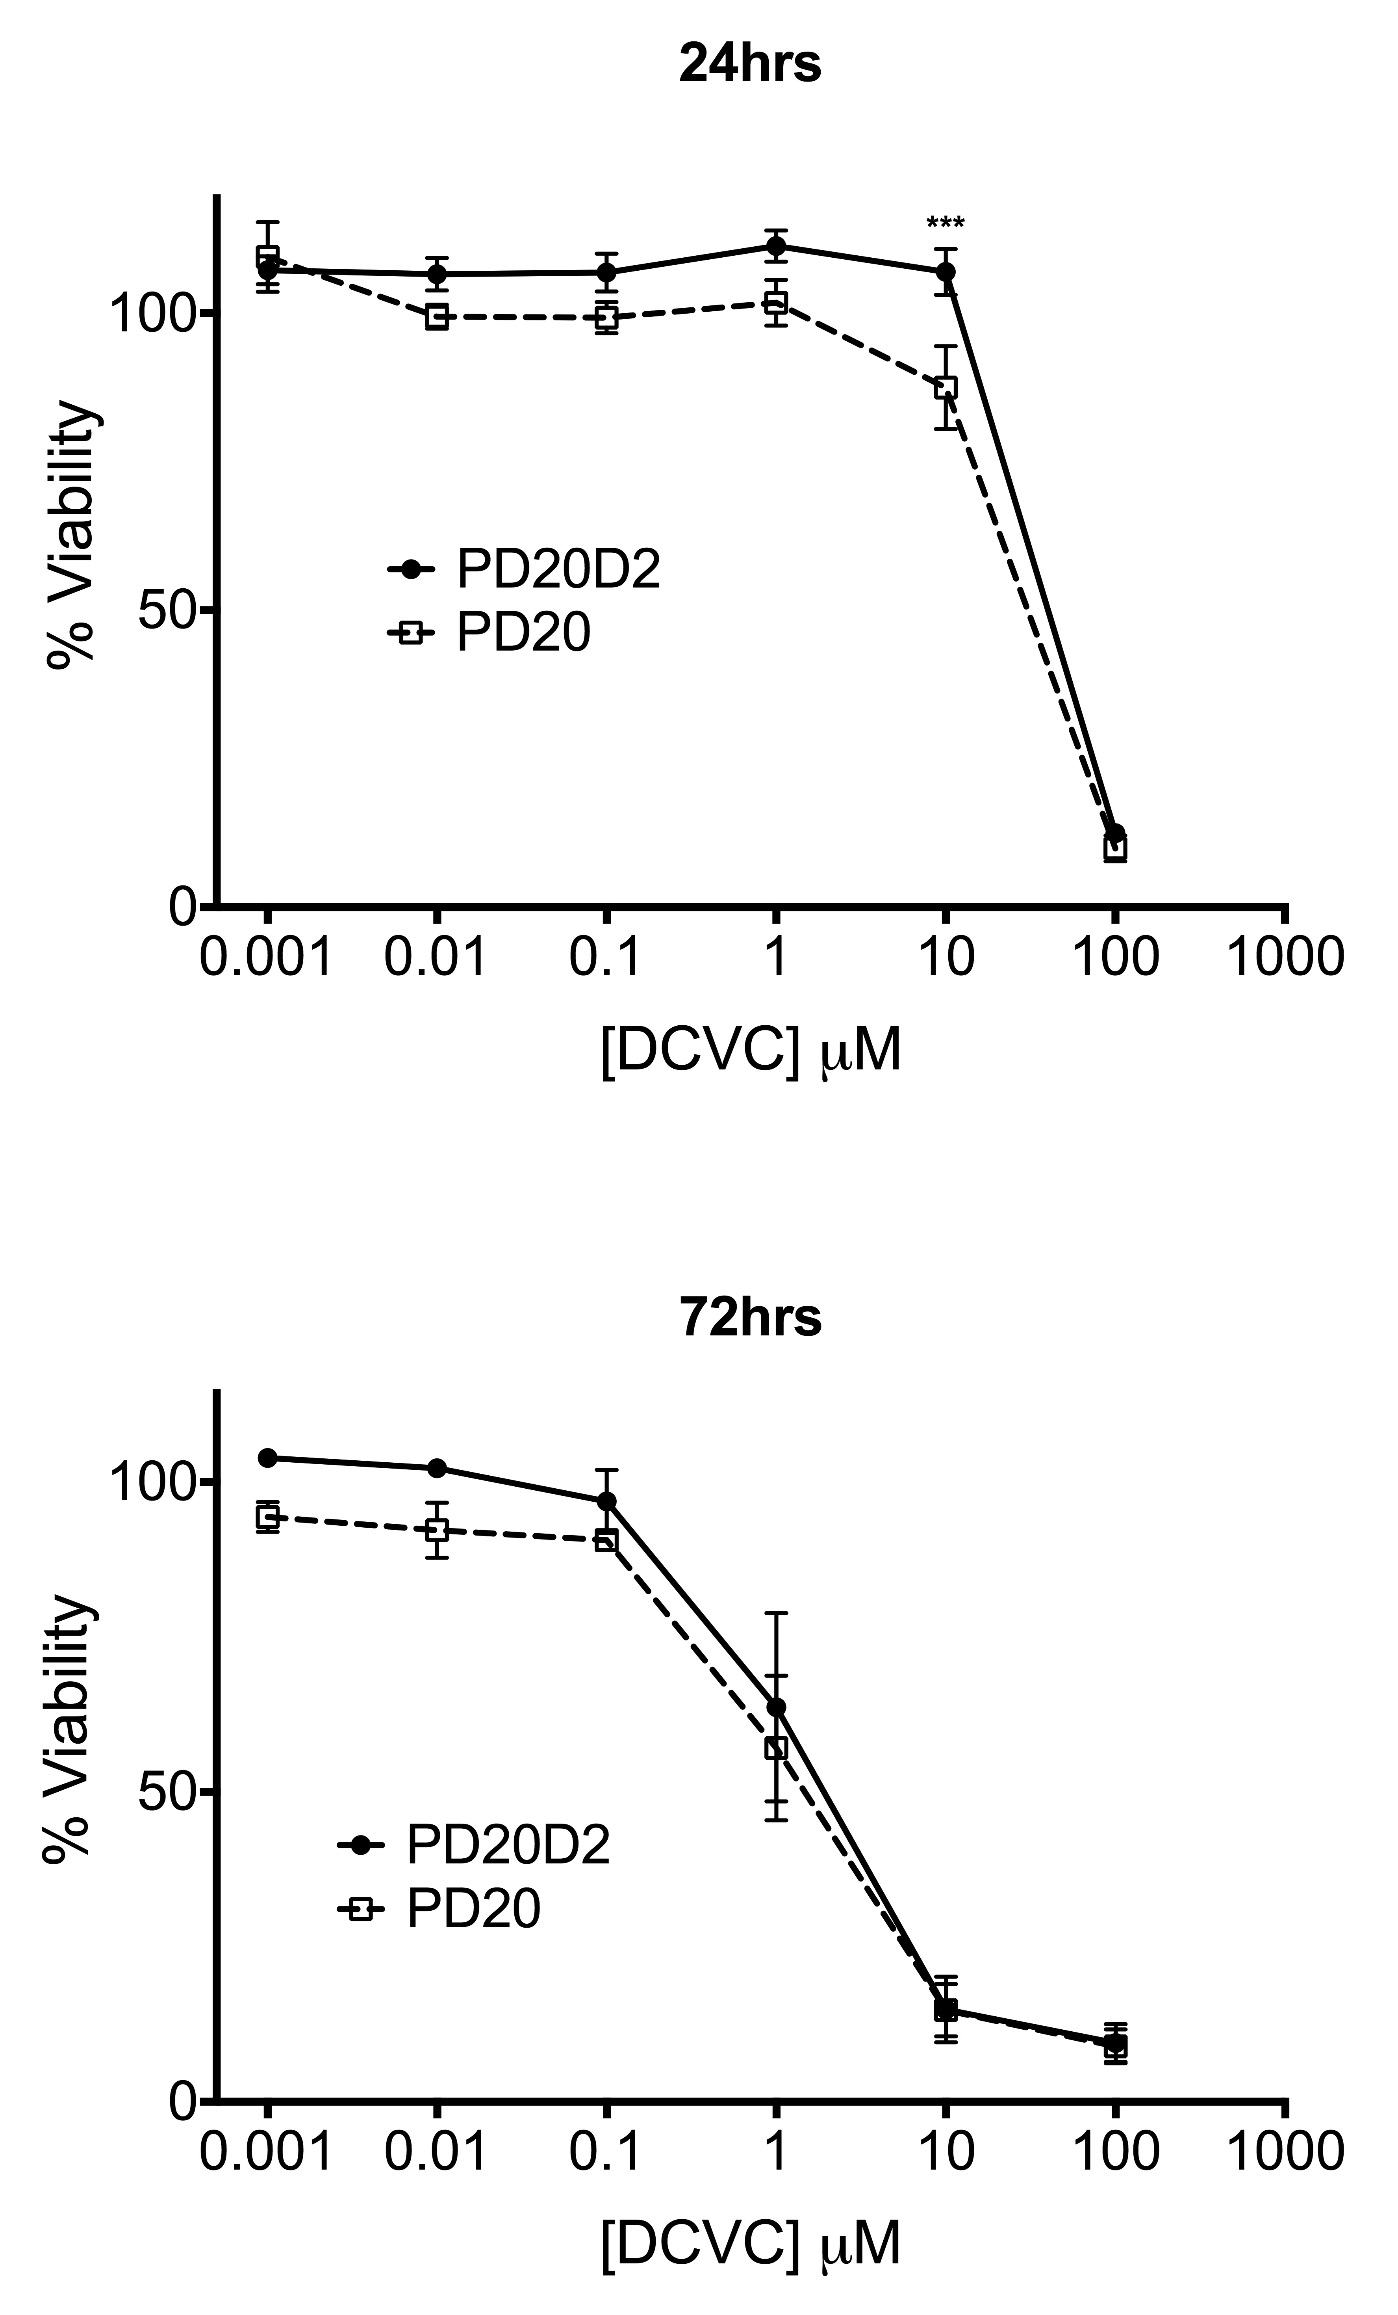

**Figure S4**. Sensitivity of ICL repair deficient lymphoblasts (PD20) and FANCD2 complemented (PD20D2) cells to DCVC at 24hrs and 72hrs. Values are mean ± SE; n = 3 for each measurement. Values are mean ± SE; n ≥ 3 for each measurement. Significance values were calculated by two-way ANOVA, where ***p < 0.001, **p < 0.01, *p < 0.05 *for DCVC-treated PD20 versus DCVC treated PD20*

**Table S1.** Total genes identified by differential strain sensitivity analysis (DSSA) from yeast profiling studies as sensitive or resistant to DCVC treatments.

|  |  |  |  |  |  |
| --- | --- | --- | --- | --- | --- |
| ORF | Standard Name | 5 generations | | | Number of Significant |
| 25% IC20 | 50% IC20 | IC20 |
| 4.5 µM | 9 µM | 18 µM |
| *YIL162W* | *SUC2* | -4.2 | -4.1 | -4 | 3 |
| *YFR036W* | *CDC26* | -3.2 | -3.8 | -3.05 | 3 |
| *YDR112W* | *IRC2* | -2.7 | -4 | -2.95 | 3 |
| *YLR032W* | *RAD5* |  | -2.2 | -2.7 | 2 |
| *YCR066W* | *RAD18* |  | -2.1 | -2.4 | 2 |
| *YBR171W* | *SEC66* |  | -2 | -2.4 | 2 |
| *YAL002W* | *VPS8* |  | -1.8 | -2.3 | 2 |
| *YOR304C-A* |  | -2 | -2.5 | -2.2 | 3 |
| *YML097C* | *VPS9* |  | -2.3 | -2.2 | 2 |
| *YKL188C* | *PXA2* |  |  | -2 | 1 |
| *YMR141C* |  |  |  | -2 | 1 |
| *YOR089C* | *VPS21* |  | -1.9 | -1.95 | 2 |
| *YGL154C* | *LYS5* |  |  | -1.8 | 1 |
| *YDR338C* |  |  |  | -1.8 | 1 |
| *YKL199C* |  |  |  | -1.8 | 1 |
| *YML095C* | *RAD10* |  |  | -1.8 | 1 |
| *YMR137C* | *PSO2* |  | -1.8 | -1.75 | 2 |
| *YGL164C* | *YRB30* | -1.6 | -1.5 | -1.7 | 3 |
| *YAL024C* | *LTE1* |  |  | -1.7 | 1 |
| *YDR247W* | *VHS1* |  |  | -1.7 | 1 |
| *YER095W* | *RAD51* |  |  | -1.7 | 1 |
| *YPL022W* | *RAD1* |  |  | -1.65 | 1 |
| *YLR218C* |  |  | -1.5 | -1.6 | 2 |
| *YER162C* | *RAD4* |  |  | -1.6 | 1 |
| *YKR046C* | *PET10* | -1.4 |  | -1.5 | 2 |
| *YMR237W* | *BCH1* | -1.2 |  | -1.5 | 2 |
| *YGL166W* | *CUP2* |  |  | -1.4 | 1 |
| *YPL147W* | *PXA1* |  |  | -1.4 | 1 |
| *YIL146C* | *ECM37* |  |  | -1.4 | 1 |
| *YKL167C* | *MRP49* |  |  | -1.4 | 1 |
| *YGL253W* | *HXK2* |  |  | -1.4 | 1 |
| *YKL215C* |  | -1.3 | -1.1 | -1.3 | 3 |
| *YKL197C* | *PEX1* | -1.4 |  | -1.3 | 2 |
| *YER067W* |  | -1.3 |  | -1.3 | 2 |
| *YKR033C* |  | -1.3 |  | -1.3 | 2 |
| *YOR346W* | *REV1* |  |  | -1.3 | 1 |
| *YLR210W* | *CLB4* |  |  | -1.3 | 1 |
| *YOR017W* | *PET127* |  |  | -1.3 | 1 |
| *YHR110W* | *ERP5* |  |  | -1.3 | 1 |
| *YDR291W* | *HRQ1* |  |  | -1.3 | 1 |
| *YMR008C* | *PLB1* |  |  | -1.2 | 1 |
| *YML109W* | *ZDS2* |  |  | -1.2 | 1 |
| *YMR283C* | *RIT1* |  |  | -1.2 | 1 |
| *YKL100C* |  |  |  | -1.1 | 1 |
| *YDL034W* |  |  |  | 1.2 | 1 |
| *YJR154W* |  |  |  | 1.3 | 1 |
| *YDR463W* | *STP1* |  |  | 1.3 | 1 |
| *YCR082W* | *AHC2* |  | 1.5 | 1.4 | 2 |
| *YOR006C* |  |  |  | 1.4 | 1 |
| *YDR333C* |  |  |  | 1.4 | 1 |
| *YPL123C* | *RNY1* |  |  | 1.4 | 1 |
| *YCR001W* |  |  | 1.6 | 1.5 | 2 |
| *YJR051W* | *OSM1* |  | 1.6 | 1.5 | 2 |
| *YMR238W* | *DFG5* |  | 2.1 | 1.5 | 2 |
| *YMR124W* |  | 1.4 |  | 1.5 | 2 |
| *YGL198W* | *YIP4* | 1.4 |  | 1.5 | 2 |
| *YDR440W* | *DOT1* |  |  | 1.5 | 1 |
| *YML124C* | *TUB3* |  |  | 1.55 | 1 |
| *YCR060W* | *TAH1* | 1.2 | 1.4 | 1.6 | 3 |
| *YOR085W* | *OST3* |  | 1.5 | 1.6 | 2 |
| *YLR093C* | *NYV1* | 2.1 | 1.6 | 1.6 | 3 |
| *YBL107C* |  |  | 1.7 | 1.6 | 2 |
| *YPR201W* | *ARR3* |  | 1.7 | 1.6 | 2 |
| *YOR183W* | *FYV12* |  | 1.7 | 1.6 | 2 |
| *YOR137C* | *SIA1* | 1.7 | 1.8 | 1.6 | 3 |
| *YDR217C* | *RAD9* | 1.6 |  | 1.6 | 2 |
| *YLR023C* | *IZH3* |  |  | 1.6 | 1 |
| *YJL208C* | *NUC1* | 1.6 | 1.6 | 1.7 | 3 |
| *YPL197C* |  | 1.6 | 1.6 | 1.7 | 3 |
| *YGR192C* | *TDH3* | 1.7 | 1.9 | 1.7 | 3 |
| *YGR263C* | *SAY1* |  | 2.2 | 1.7 | 2 |
| *YDR441C* | *APT2* | 1.9 | 1.8 | 1.8 | 3 |
| *YLR202C* |  | 2 | 1.8 | 1.8 | 3 |
| *YML073C* | *RPL6A* |  | 1.8 | 1.8 | 2 |
| *YGL214W* |  |  | 1.8 | 1.8 | 2 |
| *YMR286W* | *MRPL33* | 1.9 | 2 | 1.8 | 3 |
| *YHR034C* | *PIH1* |  | 2 | 1.8 | 2 |
| *YKR035C* | *OPI8* |  | 2.4 | 1.8 | 2 |
| *YMR244C-A* |  |  | 2.8 | 1.8 | 2 |
| *YPL178W* | *CBC2* |  | 3 | 1.8 | 2 |
| *YCR011C* | *ADP1* |  | 1.8 | 1.9 | 2 |
| *YLR042C* |  | 2 | 1.9 | 1.9 | 3 |
| *YDR465C* | *RMT2* |  | 1.9 | 1.9 | 2 |
| *YEL068C* |  |  | 2 | 1.9 | 2 |
| *YMR294W-A* |  |  | 2.6 | 1.9 | 2 |
| *YGL252C* | *RTG2* |  |  | 1.9 | 1 |
| *YPL140C* | *MKK2* | 2.1 | 1.6 | 2 | 3 |
| *YLR057W* |  | 2.2 | 1.6 | 2 | 3 |
| *YMR272C* | *SCS7* | 2.3 | 1.9 | 2.1 | 3 |
| *YDR255C* | *RMD5* | 2.1 | 2.2 | 2.1 | 3 |
| *YJR130C* | *STR2* |  | 2.2 | 2.1 | 2 |
| *YOR021C* |  | 2.3 | 2.4 | 2.1 | 3 |
| *YFR018C* |  |  | 3.1 | 2.1 | 2 |
| *YFL021W* | *GAT1* |  |  | 2.1 | 1 |
| *YJL131C* |  |  |  | 2.1 | 1 |
| *YMR289W* | *ABZ2* | 2.5 | 2.4 | 2.15 | 3 |
| *YCL046W* |  | 1.9 | 1.9 | 2.2 | 3 |
| *YDR215C* |  | 1.8 | 2.1 | 2.2 | 3 |
| *YIL032C* |  |  | 2.1 | 2.2 | 2 |
| *YOR314W* |  | 2.5 | 2.3 | 2.2 | 3 |
| *YBR272C* | *HSM3* | 1.7 |  | 2.2 | 2 |
| *YFL025C* | *BST1* |  |  | 2.2 | 1 |
| *YIL090W* | *ICE2* | 2.1 | 2.6 | 2.3 | 3 |
| *YLR133W* | *CKI1* |  | 2.7 | 2.3 | 2 |
| *YHL039W* |  |  |  | 2.3 | 1 |
| *YML122C* |  |  | 2 | 2.4 | 2 |
| *YPR116W* |  | 2.8 | 2.2 | 2.4 | 3 |
| *YHR037W* | *PUT2* |  | 2.4 | 2.4 | 2 |
| *YOR133W* | *EFT1* |  | 3.1 | 2.4 | 2 |
| *YBR298C* | *MAL31* | 2.2 |  | 2.4 | 2 |
| *YDR389W* | *SAC7* |  |  | 2.4 | 1 |
| *YBR159W* | *IFA38* | 2.4 | 2 | 2.5 | 3 |
| *YLR262C* | *YPT6* | 2.5 | 2.1 | 2.5 | 3 |
| *YLR044C* | *PDC1* | 2.7 | 2.3 | 2.5 | 3 |
| *YMR166C* |  |  | 2.4 | 2.5 | 2 |
| *YBR113W* |  | 2.6 | 2.6 | 2.5 | 3 |
| *YER169W* | *RPH1* | 2.5 | 2.9 | 2.5 | 3 |
| *YDR153C* | *ENT5* |  | 3.1 | 2.5 | 2 |
| *YGR261C* | *APL6* |  | 3.7 | 2.5 | 2 |
| *YLR169W* |  | 2.6 | 2.3 | 2.6 | 3 |
| *YDR105C* | *TMS1* | 2.6 | 2.7 | 2.6 | 3 |
| *YGL229C* | *SAP4* | 2.5 | 2.4 | 2.7 | 3 |
| *YGL226C-A* | *OST5* | 2.5 | 2.5 | 2.7 | 3 |
| *YBR114W* | *RAD16* | 2.7 | 2.7 | 2.7 | 3 |
| *YCR006C* |  | 2.6 | 2.8 | 2.7 | 3 |
| *YGL138C* |  | 2.8 | 3 | 2.7 | 3 |
| *YBR175W* | *SWD3* |  | 3.9 | 2.7 | 2 |
| *YDL223C* | *HBT1* | 1.5 | 2.25 | 2.8 | 3 |
| *YDR175C* | *RSM24* | 2.8 | 2.3 | 2.8 | 3 |
| *YCR073W-A* | *SOL2* | 2.5 | 2.5 | 2.8 | 3 |
| *YHL011C* | *PRS3* | 3 | 2.6 | 2.8 | 3 |
| *YDR377W* | *ATP17* | 3.1 | 2.8 | 2.8 | 3 |
| *YDR456W* | *NHX1* | 3.5 | 2.9 | 2.8 | 3 |
| *YEL012W* | *UBC8* |  | 3.9 | 2.8 | 2 |
| *YJR044C* | *VPS55* | 2.8 | 2.8 | 2.9 | 3 |
| *YER066C-A* |  | 2.7 | 2.9 | 2.9 | 3 |
| *YLR450W* | *HMG2* | 3.3 | 2.8 | 3 | 3 |
| *YER002W* | *NOP16* | 3 | 3 | 3 | 3 |
| *YJR088C* |  | 3.2 | 3.1 | 3 | 3 |
| *YBR213W* | *MET8* | 3.1 | 3.1 | 3.1 | 3 |
| *YDR163W* | *CWC15* | 3 | 2.9 | 3.2 | 3 |
| *YPL157W* | *TGS1* |  | 3.8 | 3.2 | 2 |
| *YHR157W* | *REC104* | 3.2 | 3.1 | 3.3 | 3 |
| *YMR304W* | *UBP15* | 3.3 | 2.9 | 3.4 | 3 |
| *YMR261C* | *TPS3* | 3.3 | 2.9 | 3.5 | 3 |
| *YDR458C* | *HEH2* | 3.6 | 3.7 | 3.8 | 3 |
| *YBR187W* | *GDT1* | 4 | 4 | 4.3 | 3 |
| *YML079W* |  |  |  | 4.3 | 1 |
| *YEL056W* | *HAT2* | -3.5 | -3.1 |  | 2 |
| *YEL043W* |  | -3.3 | -2.8 |  | 2 |
| *YPL138C* | *SPP1* | -1.9 | -2.1 |  | 2 |
| *YPL167C* | *REV3* |  | -1.7 |  | 1 |
| *YKL097C* |  |  | -1.4 |  | 1 |
| *YOR253W* | *NAT5* |  | -1.3 |  | 1 |
| *YMR326C* |  |  | 1.1 |  | 1 |
| *YNL010W* |  | 1.4 | 1.2 |  | 2 |
| *YLR121C* | *YPS3* | 1.6 | 1.4 |  | 2 |
| *YLR098C* | *CHA4* |  | 1.6 |  | 1 |
| *YDR314C* | *RAD34* |  | 1.6 |  | 1 |
| *YDR283C* | *GCN2* |  | 1.6 |  | 1 |
| *YJL108C* | *PRM10* | 1.6 | 1.7 |  | 2 |
| *YDR251W* | *PAM1* | 1.7 | 1.7 |  | 2 |
| *YLR192C* | *HCR1* | 1.7 | 1.7 |  | 2 |
| *YBL008W* | *HIR1* |  | 1.7 |  | 1 |
| *YML048W-A* |  | 1.7 | 1.8 |  | 2 |
| *YHR046C* | *INM1* |  | 1.9 |  | 1 |
| *YFL013W-A* |  |  | 1.9 |  | 1 |
| *YDR285W* | *ZIP1* |  | 1.9 |  | 1 |
| *YHR160C* | *PEX18* |  | 1.9 |  | 1 |
| *YKL096W-A* | *CWP2* |  | 1.9 |  | 1 |
| *YGR041W* | *BUD9* |  | 2 |  | 1 |
| *YOR161C* | *PNS1* |  | 2 |  | 1 |
| *YOR364W* |  |  | 2 |  | 1 |
| *YPR044C* | *OPI11* |  | 2 |  | 1 |
| *YJR010C-A* | *SPC1* |  | 2 |  | 1 |
| *YBR037C* | *SCO1* |  | 2.1 |  | 1 |
| *YKL174C* | *TPO5* |  | 2.1 |  | 1 |
| *YMR280C* | *CAT8* |  | 2.2 |  | 1 |
| *YMR262W* |  |  | 2.2 |  | 1 |
| *YBL062W* |  |  | 2.4 |  | 1 |
| *YLR335W* | *NUP2* | 1.6 | 2.5 |  | 2 |
| *YFL032W* |  |  | 2.5 |  | 1 |
| *YPL035C* |  |  | 2.5 |  | 1 |
| *YGL118C* |  |  | 2.5 |  | 1 |
| *YNL101W* | *AVT4* |  | 2.5 |  | 1 |
| *YFL019C* |  |  | 2.7 |  | 1 |
| *YOR086C* | *TCB1* | 3 | 2.8 |  | 2 |
| *YGL071W* | *AFT1* | -2.5 |  |  | 1 |
| *YOR276W* | *CAF20* | -2.2 |  |  | 1 |
| *YFL003C* | *MSH4* | -1.9 |  |  | 1 |
| *YOR054C* | *VHS3* | -1.8 |  |  | 1 |
| *YIL089W* |  | -1.6 |  |  | 1 |
| *YDR057W* | *YOS9* | -1.4 |  |  | 1 |
| *YLR131C* | *ACE2* | 1.3 |  |  | 1 |
| *YNL058C* |  | 1.4 |  |  | 1 |
| *YLR099C* | *ICT1* | 1.4 |  |  | 1 |
| *YOR041C* |  | 1.4 |  |  | 1 |
| *YLR018C* | *POM34* | 1.4 |  |  | 1 |
| *YLR456W* |  | 1.5 |  |  | 1 |
| *YLR443W* | *ECM7* | 1.5 |  |  | 1 |
| *YLR053C* |  | 1.6 |  |  | 1 |
| *YLR049C* |  | 1.7 |  |  | 1 |
| *YGR183C* | *QCR9* | 1.7 |  |  | 1 |
| *YMR175W* | *SIP18* | 1.8 |  |  | 1 |
| *YLR270W* | *DCS1* | 1.8 |  |  | 1 |
| *YBR044C* | *TCM62* | 1.9 |  |  | 1 |
| *YLR257W* |  | 2 |  |  | 1 |
| *YOR199W* |  | 2 |  |  | 1 |
| *YIL139C* | *REV7* | 2.2 |  |  | 1 |
| *YOR201C* | *MRM1* | 2.2 |  |  | 1 |
| *YLL009C* | *COX17* | 2.8 |  |  | 1 |

**Table S2**. Mutation frequency (mean ± SE x 10-6 cells) of DCVC in human lymphoblast cellsa

|  |  |  |
| --- | --- | --- |
| DCVC (μM) | MF | Fold changeb |
| 0 | 5.8 ± 1.8 |  |
| 2 | 12.8 ± 1.5** | 2.2 |
| 4 | 13.2 ± 1.6* | 2.3 |
| 8 | 10.3 ± 4.0 | 1.8 |
| 15 | 11.6 ± 1.7 | 2.0 |

aMutagenesis at the TK locus was measured in human lymphoblasts after exposure to DCVC for 6 weeks. Mutation frequency is the number of mutation events per 1 million cells. Values are mean ± SE; n = 2 for each measurement. **p < 0.01, *p < 0.05 for DCVC-treated versus untreated

bFold increase compared to untreated control.

**Table S3.** DT40 mutant cells used in this study

|  |  |  |
| --- | --- | --- |
| Gene | Function | References |
| POLβ | Base excision repair | (Tano et al., 2007) |
| FEN1 | Base excision repair | (Matsuzaki et al., 2002) |
| PARP1 | Base excision repair | (Hochegger et al., 2006) |
| XPA | Nucleotide excision repair | (Okada et al., 2002) |
| XPG | Nucleotide excision repair | (Kikuchi et al., 2005) |
| WRN | DNA helicase | (Kawabe et al., 2006) |
| BLM | DNA helicase | (Wang et al., 2000) |
| FANCD2 | Fanconi anemia pathway | (Yamamoto et al., 2005) |
| BRCA1 | Fanconi anemia pathway | (Vandenberg et al., 2003) |
| BRCA2 | Fanconi anemia pathway | (Hatanaka et al., 2005) |
| XRCC2 | Homologous recombination | (Takata et al., 2001) |
| XRCC3 | Homologous recombination | (Takata et al., 2001) |
| RAD52 | Homologous recombination | (Yamaguchi-Iwai et al., 1998) |
| RAD51D | Homologous recombination | (Takata et al., 2001) |
| RAD54 | Homologous recombination | (Bezzubova et al., 1997) |
| KU70 | Non-homologous end joining | (Takata et al., 1998) |
| LIGIV | Non-homologous end joining | (Adachi et al., 2001) |
| DNA-PK | Non-homologous end joining | (Fukushima et al., 2001) |
| RAD9 | DNA damage checkpoint | (Kobayashi et al., 2004) |
| ATM | DNA damage checkpoint | (Takao et al., 1999) |
| RAD17 | DNA damage checkpoint | (Kobayashi et al., 2004) |
| REV1 | Translesion synthesis repair | (Simpson and Sale, 2003) |
| POLQ | Translesion synthesis repair | (Yoshimura et al., 2006) |
| PCNAK164R | Translesion synthesis repair | (Arakawa et al., 2006) |
| RAD18 | Translesion synthesis repair | (Yamashita et al., 2002) |

**SUPPLEMENTAL REFERENCES**

Adachi, N., Ishino, T., Ishii, Y., Takeda, S., Koyama, H., 2001. DNA ligase IV-deficient cells are more resistant to ionizing radiation in the absence of Ku70: Implications for DNA double-strand break repair. P Natl Acad Sci Usa 98, 12109–12113. doi:10.1073/pnas.201271098

Arakawa, H., Moldovan, G.-L., Saribasak, H., Saribasak, N.N., Jentsch, S., Buerstedde, J.-M., 2006. A role for PCNA ubiquitination in immunoglobulin hypermutation. Plos Biol 4, e366. doi:10.1371/journal.pbio.0040366

Bezzubova, O., Silbergleit, A., Yamaguchi-Iwai, Y., Takeda, S., Buerstedde, J.M., 1997. Reduced X-ray resistance and homologous recombination frequencies in a RAD54-/- mutant of the chicken DT40 cell line. Cell 89, 185–193.

Fukushima, T., Takata, M., Morrison, C., Araki, R., Fujimori, A., Abe, M., Tatsumi, K., Jasin, M., Dhar, P.K., Sonoda, E., Chiba, T., Takeda, S., 2001. Genetic analysis of the DNA-dependent protein kinase reveals an inhibitory role of Ku in late S-G2 phase DNA double-strand break repair. J Biol Chem 276, 44413–44418. doi:10.1074/jbc.M106295200

Hatanaka, A., Yamazoe, M., Sale, J.E., Takata, M., Yamamoto, K., Kitao, H., Sonoda, E., Kikuchi, K., Yonetani, Y., Takeda, S., 2005. Similar effects of Brca2 truncation and Rad51 paralog deficiency on immunoglobulin V gene diversification in DT40 cells support an early role for Rad51 paralogs in homologous recombination. Mol Cell Biol 25, 1124–1134. doi:10.1128/MCB.25.3.1124-1134.2005

Hochegger, H., Dejsuphong, D., Fukushima, T., Morrison, C., Sonoda, E., Schreiber, V., Zhao, G.Y., Saberi, A., Masutani, M., Adachi, N., Koyama, H., de Murcia, G., Takeda, S., 2006. Parp-1 protects homologous recombination from interference by Ku and Ligase IV in vertebrate cells. Embo J 25, 1305–1314. doi:10.1038/sj.emboj.7601015

Kawabe, Y.-I., Seki, M., Yoshimura, A., Nishino, K., Hayashi, T., Takeuchi, T., Iguchi, S., Kusa, Y., Ohtsuki, M., Tsuyama, T., Imamura, O., Matsumoto, T., Furuichi, Y., Tada, S., Enomoto, T., 2006. Analyses of the interaction of WRNIP1 with Werner syndrome protein (WRN) in vitro and in the cell. Dna Repair 5, 816–828. doi:10.1016/j.dnarep.2006.04.006

Kikuchi, K., Taniguchi, Y., Hatanaka, A., Sonoda, E., Hochegger, H., Adachi, N., Matsuzaki, Y., Koyama, H., van Gent, D.C., Jasin, M., Takeda, S., 2005. Fen-1 facilitates homologous recombination by removing divergent sequences at DNA break ends. Mol Cell Biol 25, 6948–6955. doi:10.1128/MCB.25.16.6948-6955.2005

Kobayashi, M., Hirano, A., Kumano, T., Xiang, S.-L., Mihara, K., Haseda, Y., Matsui, O., Shimizu, H., Yamamoto, K.-I., 2004. Critical role for chicken Rad17 and Rad9 in the cellular response to DNA damage and stalled DNA replication. Genes Cells 9, 291–303. doi:10.1111/j.1356-9597.2004.00728.x

Matsuzaki, Y., Adachi, N., Koyama, H., 2002. Vertebrate cells lacking FEN-1 endonuclease are viable but hypersensitive to methylating agents and H2O2. Nucleic Acids Res 30, 3273–3277.

Munari, F.M., Guecheva, T.N., Bonatto, D., Henriques, J.A.P., 2013. New features on Pso2 protein family in DNA interstrand cross-link repair and in the maintenance of genomic integrity in Saccharomyces cerevisiae. Fungal Genet. Biol. 60, 122–132. doi:10.1016/j.fgb.2013.09.003

Okada, T., Sonoda, E., Yamashita, Y.M., Koyoshi, S., Tateishi, S., Yamaizumi, M., Takata, M., Ogawa, O., Takeda, S., 2002. Involvement of vertebrate polkappa in Rad18-independent postreplication repair of UV damage. J Biol Chem 277, 48690–48695. doi:10.1074/jbc.M207957200

Simpson, L.J., Sale, J.E., 2003. Rev1 is essential for DNA damage tolerance and non-templated immunoglobulin gene mutation in a vertebrate cell line. Embo J 22, 1654–1664. doi:10.1093/emboj/cdg161

Symington, L.S., Gautier, J., 2011. Double-strand break end resection and repair pathway choice. Annu Rev Genet 45, 247–271. doi:10.1146/annurev-genet-110410-132435

Takao, N., Kato, H., Mori, R., Morrison, C., Sonada, E., Sun, X., Shimizu, H., Yoshioka, K., Takeda, S., Yamamoto, K., 1999. Disruption of ATM in p53-null cells causes multiple functional abnormalities in cellular response to ionizing radiation. Oncogene 18, 7002–7009. doi:10.1038/sj.onc.1203172

Takata, M., Sasaki, M.S., Sonoda, E., Morrison, C., Hashimoto, M., Utsumi, H., Yamaguchi-Iwai, Y., Shinohara, A., Takeda, S., 1998. Homologous recombination and non-homologous end-joining pathways of DNA double-strand break repair have overlapping roles in the maintenance of chromosomal integrity in vertebrate cells. Embo J 17, 5497–5508. doi:10.1093/emboj/17.18.5497

Takata, M., Sasaki, M.S., Tachiiri, S., Fukushima, T., Sonoda, E., Schild, D., Thompson, L.H., Takeda, S., 2001. Chromosome instability and defective recombinational repair in knockout mutants of the five Rad51 paralogs. Mol Cell Biol 21, 2858–2866. doi:10.1128/MCB.21.8.2858-2866.2001

Tano, K., Nakamura, J., Asagoshi, K., Arakawa, H., Sonoda, E., Braithwaite, E.K., Prasad, R., Buerstedde, J.-M., Takeda, S., Watanabe, M., Wilson, S.H., 2007. Interplay between DNA polymerases beta and lambda in repair of oxidation DNA damage in chicken DT40 cells. Dna Repair 6, 869–875. doi:10.1016/j.dnarep.2007.01.011

Vandenberg, C.J., Gergely, F., Ong, C.Y., Pace, P., Mallery, D.L., Hiom, K., Patel, K.J., 2003. BRCA1-independent ubiquitination of FANCD2. Mol Cell 12, 247–254.

Wang, W., Seki, M., Narita, Y., Sonoda, E., Takeda, S., Yamada, K., Masuko, T., Katada, T., Enomoto, T., 2000. Possible association of BLM in decreasing DNA double strand breaks during DNA replication. Embo J 19, 3428–3435. doi:10.1093/emboj/19.13.3428

Yamaguchi-Iwai, Y., Sonoda, E., Buerstedde, J.M., Bezzubova, O., Morrison, C., Takata, M., Shinohara, A., Takeda, S., 1998. Homologous recombination, but not DNA repair, is reduced in vertebrate cells deficient in RAD52. Mol Cell Biol 18, 6430–6435.

Yamamoto, K., Hirano, S., Ishiai, M., Morishima, K., Kitao, H., Namikoshi, K., Kimura, M., Matsushita, N., Arakawa, H., Buerstedde, J.-M., Komatsu, K., Thompson, L.H., Takata, M., 2005. Fanconi anemia protein FANCD2 promotes immunoglobulin gene conversion and DNA repair through a mechanism related to homologous recombination. Mol Cell Biol 25, 34–43. doi:10.1128/MCB.25.1.34-43.2005

Yamashita, Y.M., Okada, T., Matsusaka, T., Sonoda, E., Zhao, G.Y., Araki, K., Tateishi, S., Yamaizumi, M., Takeda, S., 2002. RAD18 and RAD54 cooperatively contribute to maintenance of genomic stability in vertebrate cells. Embo J 21, 5558–5566. doi:10.1093/emboj/cdf534

Yoshimura, M., Kohzaki, M., Nakamura, J., Asagoshi, K., Sonoda, E., Hou, E., Prasad, R., Wilson, S.H., Tano, K., Yasui, A., Lan, L., Seki, M., Wood, R.D., Arakawa, H., Buerstedde, J.-M., Hochegger, H., Okada, T., Hiraoka, M., Takeda, S., 2006. Vertebrate POLQ and POLbeta cooperate in base excision repair of oxidative DNA damage. Mol Cell 24, 115–125. doi:10.1016/j.molcel.2006.07.032